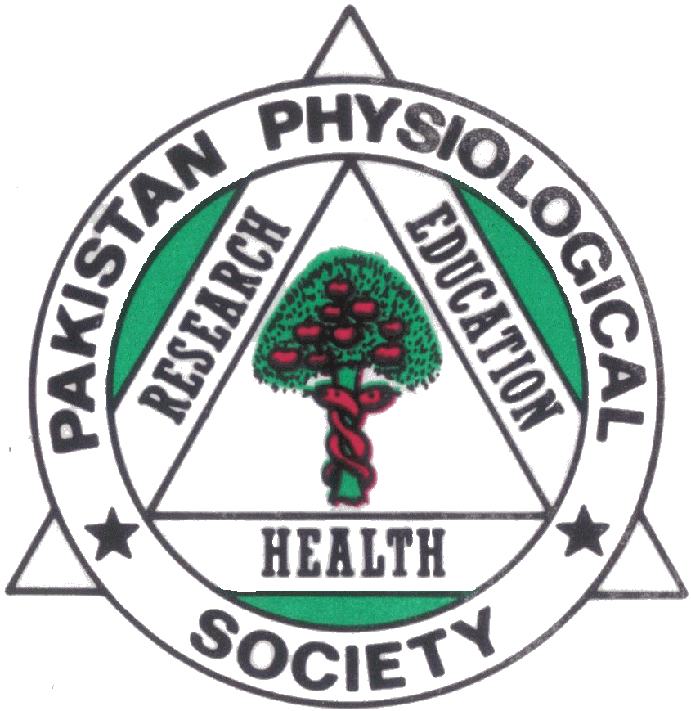   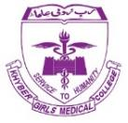 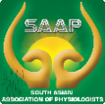 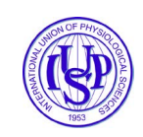

**18th Pakistan Physiological Society International (Hybrid) Conference 2023**

**6th-8th October, 2023**

**“Where there is life, there is Physiology”**

**PRE- CONFERENCE WORKSHOP CONCEPT FORM**

**Workshop Title:**

………………………………………………………………………………………………………………………………..

**Aims:** ………………………………………………………………………………………………………………………..

**Learning Outcomes**: At the end of workshop, participants will be able to;

1. ………………………………………………………………………………………………………………………
2. ……………………………………………………………………………………………………………………..
3. ……………………………………………………………………………………………………………………..

**Target audience**: ……………………………………………………………………………………………………..

(Students, Faculty, researchers, fellows and technicians)

**Physical/Online:** ……………………………………………………………

**Maximum participants**: …………………………………………………

**Requirements:** …………………………………………………………………………………………………………

**Venue:** ……………………………………………………………….

**Facilitators:**

**Names designations and email address:**

1. …………………………………………………………………………………………………………….
2. …………………………………………………………………………………………………………….
3. …………………………………………………………………………………………………………….

**Submission Deadline: 15th July, 2023**

**Submit at: [pps18.conference@gmail.com](mailto:pps18.conference@gmail.com)**